Deadlock
A Deadlock is a situation in a database where two or more transactions wait for each other forever, so none of them can continue its execution.

Easy Definition (1 Line)
Deadlock occurs when transactions keep waiting for each other indefinitely.

বাংলায়
যখন দুই বা ততোধিক Transaction একে অপরের জন্য অপেক্ষা করতে থাকে এবং কেউই কাজ শেষ করতে পারে না, তখন তাকে Deadlock বলে।

Easy Example
Suppose,
- T1 needs Data A, but it is locked by T2.
- T2 needs Data B, but it is locked by T1.
Now,
- T1 waits for T2.
- T2 waits for T1.
👉 Both keep waiting forever.
This is called Deadlock.

Wait-for Graph (WFG)

Definition
A Wait-for Graph (WFG) is a directed graph that shows which transaction is waiting for another transaction.
- Node = Transaction
- Edge (Arrow) = Waiting Relationship
If Transaction Ti is waiting for a lock held by Transaction Tj, then an edge is drawn from Ti → Tj.

Deadlock Detection Rule
A deadlock can be detected easily using a Wait-for Graph.
- If the graph contains a cycle → Deadlock exists.
- If there is no cycle → No Deadlock.

Centralized DBMS vs Distributed DBMS

In Centralized DBMS
Deadlock detection is easy because there is only one database site.
Only one Local Wait-for Graph (LWFG) is needed to detect deadlocks.

বাংলায়
Centralized DBMS-এ একটি মাত্র Site থাকে, তাই একটি LWFG দিয়েই Deadlock খুঁজে পাওয়া যায়।

In Distributed DBMS
Deadlock detection is more difficult because transactions may be waiting across multiple sites.
Therefore, drawing only the Local Wait-for Graph (LWFG) is not enough.
A Global Wait-for Graph (GWFG) must also be created.

বাংলায়
Distributed DBMS-এ Transaction বিভিন্ন Site-এ থাকে, তাই Deadlock বিভিন্ন Site জুড়ে হতে পারে। এজন্য শুধু LWFG যথেষ্ট নয়, GWFG-ও তৈরি করতে হয়।

LWFG (Local Wait-for Graph)
An LWFG shows the waiting relationships of transactions within one local site.
It is used to detect local deadlocks.

বাংলায়
LWFG শুধুমাত্র একটি Site-এর Transaction দেখায় এবং Local Deadlock শনাক্ত করে।

Easy Example
Site-1:
T1 → T2
এটি শুধু Site-1-এর তথ্য দেখায়।

GWFG (Global Wait-for Graph)
A GWFG combines the LWFGs of all sites to detect deadlocks in the entire distributed system.
An LWFG is a part of the GWFG.

বাংলায়
GWFG সব Site-এর LWFG একত্র করে তৈরি করা হয় এবং পুরো Distributed System-এর Deadlock শনাক্ত করে।
LWFG হলো GWFG-এর একটি অংশ।

Easy Example
Suppose there are 3 sites.
- Site-1 has LWFG
- Site-2 has LWFG
- Site-3 has LWFG
Individually, none of them has a cycle.
But after combining them into a GWFG, a cycle appears.
👉 Therefore, a Global Deadlock exists.

Three Techniques of Deadlock Resolution

1. Distributed Deadlock Prevention
This method prevents a deadlock before it occurs. If the system detects that a transaction may cause a deadlock, it aborts or restarts one transaction.

Easy Example
T1 wants a lock held by T2.
The system predicts a deadlock.
👉 T1 is stopped before the deadlock happens.

বাংলায়
Deadlock হওয়ার আগেই System একটি Transaction বন্ধ করে দেয়, যাতে Deadlock না হয়।

2. Distributed Deadlock Avoidance

Definition
This method avoids deadlocks by checking whether granting a lock will create an unsafe state. A lock is granted only if the system remains safe.

Easy Example
Before giving a lock to T1, the system checks if it is safe.
If it is safe → Lock is granted.
If not → T1 must wait.

বাংলায়
Lock দেওয়ার আগে System দেখে Deadlock হওয়ার সম্ভাবনা আছে কি না। নিরাপদ হলে Lock দেয়, না হলে অপেক্ষা করায়।

3. Distributed Deadlock Detection and Recovery
This method first detects the deadlock using a Wait-for Graph (WFG). If a cycle is found, one transaction is selected as the victim, aborted, and restarted to recover from the deadlock.

Easy Example
T1 waits for T2.
T2 waits for T1.
A cycle is detected.
👉 T2 is aborted, and the deadlock is removed.
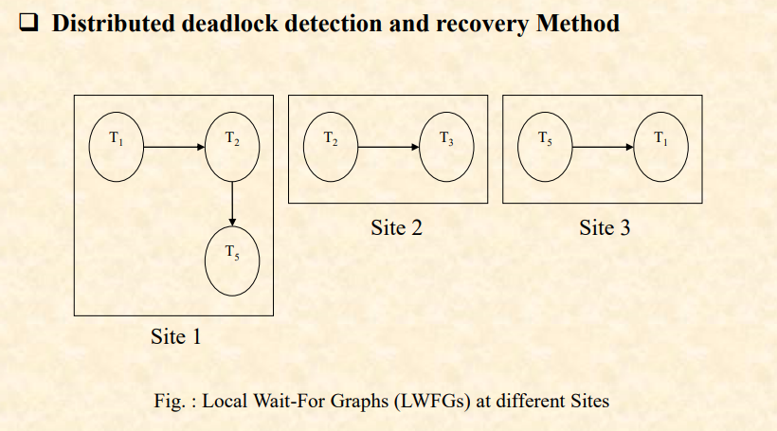
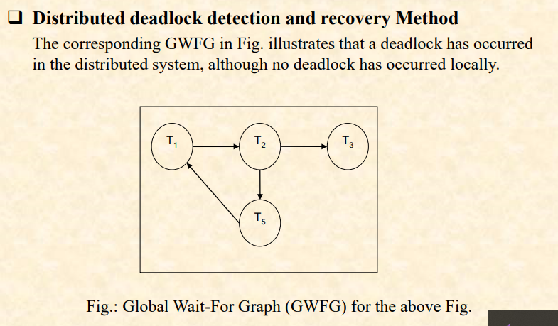

বাংলায়
প্রথমে Wait-for Graph দিয়ে Deadlock খুঁজে বের করা হয়। তারপর একটি Transaction Abort করে Deadlock দূর করা হয়।

Types of Deadlock Prevention
1. Non-Preemptive Prevention

Definition
Non-Preemptive Prevention is a deadlock prevention technique in which the requesting transaction (Ti) is aborted and restarted if there is a risk of deadlock. The transaction holding the lock (Tj) is not interrupted.

Easy Example
Suppose T1 requests a lock that is already held by T2.
The system detects a deadlock risk.
👉 T1 is aborted and restarted, while T2 continues its work.
This is called Non-Preemptive Prevention.

বাংলায় (বোঝার জন্য)
যদি Lock চাওয়া Transaction (Ti) Abort হয় এবং Lock ধরে রাখা Transaction (Tj) কাজ চালিয়ে যায়, তাহলে সেটি Non-Preemptive Prevention।

2. Preemptive Prevention
Preemptive Prevention is a deadlock prevention technique in which the transaction holding the lock (Tj) is aborted and restarted if there is a risk of deadlock. The lock is then given to the requesting transaction (Ti).

Easy Example
Suppose T1 requests a lock that is already held by T2.
The system detects a deadlock risk.
👉 T2 is aborted, and the lock is given to T1.
This is called Preemptive Prevention.

বাংলায় (বোঝার জন্য)
যদি Lock ধরে রাখা Transaction (Tj) Abort হয় এবং Lock চাওয়া Transaction (Ti) Lock পেয়ে যায়, তাহলে সেটি Preemptive Prevention।

Centralized Deadlock Detection
Centralized Deadlock Detection is a method in which one site is selected as the Deadlock Detection Coordinator (DDC) for the entire distributed database system. The DDC collects all Local Wait-for Graphs (LWFGs) from different sites, combines them into a Global Wait-for Graph (GWFG), and checks for cycles to detect deadlocks.

Easy Definition (1 Line)
Centralized Deadlock Detection uses one central site (DDC) to detect deadlocks by constructing a Global Wait-for Graph (GWFG).

বাংলায় (বোঝার জন্য)
একটি Central Site (DDC) সব Site-এর LWFG সংগ্রহ করে GWFG তৈরি করে এবং Cycle দেখে Deadlock শনাক্ত করে।

How Does It Work?
- One site is selected as the Deadlock Detection Coordinator (DDC).
- Every site sends its Local Wait-for Graph (LWFG) to the DDC.
- The DDC combines all LWFGs to create a Global Wait-for Graph (GWFG).
- The DDC checks the GWFG for cycles.
- If a cycle is found, a global deadlock exists.
- The DDC selects one transaction as the victim, aborts and restarts it to remove the deadlock.

Easy Example
Suppose there are 3 sites.
- Site-1 sends LWFG.
- Site-2 sends LWFG.
- Site-3 sends LWFG.
The DDC combines them into one GWFG.
If the GWFG contains a cycle, the DDC aborts one transaction and removes the deadlock.

Advantages
- Simple to understand and implement.
- Easy to detect global deadlocks using one coordinator.

বাংলায়
- সহজ Method।
- একটি Coordinator দিয়েই পুরো System-এর Deadlock খুঁজে পাওয়া যায়।

Disadvantages
- If the DDC fails, deadlock detection stops.
- Communication cost is high because every site sends its LWFG to the DDC.
- It may detect False Deadlocks.
- It may also cause Phantom Deadlocks, leading to unnecessary rollback and restart.

Distributed Deadlock Detection
Distributed Deadlock Detection is a method in which every site has its own deadlock detector. Each detector creates a Local Wait-for Graph (LWFG) and cooperates with other sites to detect global deadlocks.

Easy Definition (1 Line)
Distributed Deadlock Detection uses a deadlock detector at every site to detect both local and global deadlocks.

বাংলায় (বোঝার জন্য)
প্রতিটি Site-এ একটি করে Deadlock Detector থাকে। সবাই মিলে Deadlock শনাক্ত করে।

How Does It Work?
- Every site creates its own LWFG.
- An external node (Tex) is added to each LWFG.
- Tex represents transactions waiting between different sites.
- The detector checks the LWFG for cycles.
- Cycle without Tex → Local Deadlock.
- Cycle with Tex → Possible Global Deadlock.
- The LWFGs are exchanged and merged.
- If the merged graph contains a cycle, a Global Deadlock is detected.

Easy Example
Suppose there are 3 sites.
- Site-1 creates LWFG.
- Site-2 creates LWFG.
- Site-3 creates LWFG.
Each graph contains Tex.
After merging all LWFGs:
- If a cycle appears → Global Deadlock.
- If no cycle appears → No Deadlock.

